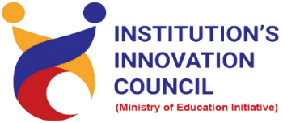
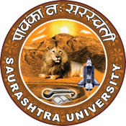
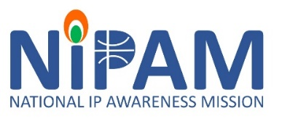
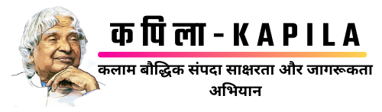

Institution's Innovation Council
Saurashtra University

The ABCs of IPR
21 February 2023
At
NFDD building
Saurashtra University, Campus, Rajkot
Contents
Saurashtra University – IIC 2
NIPAM (National Intellectual Property Awareness Mission) 2
Event Schedule 3
Event Registration Link 3
Brief about Event 4
Key Points 5
Outcome 5
About the Speaker/Chief Guest 6
Connect Us: 8

Saurashtra University – IIC

The university is dedicated to instruction, research, and extending knowledge to the public (public service). Ministry of Education (MoE), Govt. of India has established ‘MoE’s Innovation Cell (MIC)’ to systematically foster the culture of Innovation among all Higher Education Institutions (HEIs). The primary mandate of MIC is to encourage, inspire and nurture young students by supporting them to work with new ideas and transform them into prototypes while they are informative years. Saurashtra University is one the Organization that have constituted the IIC to foster the vision of MoE and be a part for the promotion and development of innovation ecosystem.

NIPAM (National Intellectual Property Awareness Mission)

National Intellectual Property Awareness Mission (NIPAM), launched in 2021, has achieved the target of imparting Intellectual Property (IP) awareness and basic training to 1 million students. The program is being implemented by the Intellectual Property Office, the Office of Controller General of Patents, Designs and Trade Marks (CGPDTM), Ministry of Commerce and Industry.
National Intellectual Property Awareness Mission (NIPAM) under the initiative of the Government's "Azadi ka Amrit Mahotsav". The pan-India ambitious mission aims to provide awareness on Intellectual Property and its rights to 1 million students. It aims to inculcate the spirit of creativity and innovation to students of higher education and ignite and inspire the students of college/Universities to innovate and protect their creations.

Event Schedule

Time | Program
11:00 am | Registration
11:00 am – 11:15 am Inauguration & Welcome
11: 00 | Inaugural Session of The ABCs of IPR
11:02 | Welcome
11:03 | Brief about IIC & Incubation Centre by Dr. Ranjan Khunt, President - IIC
11:06 | Speech by Eminent Speaker Dr. Ajay Thakur, Assistant Controller of Patents & Designs.
11:08 | Vote of Thanks by Dr. Harikrishna Parikh, Vice President – IIC
11:10 | Expert Session by Eminent Speaker Dr. Ajay Thakur, Assistant Controller of Patents & Designs.
01:30 | Question Answer Session
02:00 | Concluding and Thanks - Mr. Parth Sejpal, CEO, SU Startup And Entrepreneurship Council

Event Registration Link

bit.ly/SUSEC-ABC

Brief about Event
The Saurashtra University and IIC are organizing a workshop on "The ABCs of IPR" on 21 Feb, 2023. To foster the culture of Patent and Start-up in Saurashtra region and inspire young entrepreneurs. Ideal for students, faculty, and early-stage entrepreneurs looking to upgrade their skills and knowledge in IP law.
Intellectual property (IP) is a term used to describe original and inventive work product resulting from the human intellect, which can be legally protected by the owner from unauthorized uses. Awareness regarding various types of IP including Patent, Trademark, Design, Copyright, Integrated Circuit Design and Plant Varieties registration was carried out.
To protect IP, owners have the option of using legal tools which can help ensure compensation for the owner – either the inventor or to whomever the inventor gives or sells that ownership. IP legal tools come in the form of copyright, trademark, a patent, or a trade secret contract.
Patents protect the inventions and underlying designs of technology, product formulations, and other functional items. There are three types of patents: utility, design, and plant.
Copyrights, commonly referred to as authors’ right, protect original works of authorship that are fixed in a physical form. Copyrights apply to a broad range of works including literature, music, drama, choreography, pictures, sculptures, audio-visual and sound recordings, and architectural works.
Trademarks protect the identifying “marks” used in association with identification and origin of goods and services used by an operating business. “Marks” can mean a business name, a logo, a symbol, or even a sound.
Trade secrets can come in the form of inventions, assets, processes, and formulations created and/or owned by businesses. They are protected by contracts often referred to as non-disclosure agreements, or NDAs.
Some familiar examples of IP given by speaker:
- The Coca-Cola recipe (Trade Secret)
- The navigation device called GPS (Patent)
- Pizza Hut logo (Trademark)
- Novel, movie, Poem, etc.(copyright)
- The contours of the iPhone/iPad/iPod (Design)
- Gir Mango (GI Tag)
All these examples are protected intellectual property. Given the breadth of IP in covering such a wide variety of things, it is easy to see that IP impacts virtually everyone.

Key Points

During the session, below mentioned points were discussed:
- Types of Intellectual Property Rights
- Importance of IP
- Patent and Invention
- Fees e-filing in INR
- Geographic Indications (GI)
- SICLD (Semiconductor Integrated Circuits Layout-Design)
- How to apply for Patent, Trademark, Design and Copyrights
- FAQs related to Patent, Patent filing on Ip India portal was discussed

Outcome

As per the event, various types of IP were understood by the speaker with various examples.
Participants learned about patents, trademarks, copyrights, trade secrets, and the process of obtaining and enforcing IPR. This Intellectual Property for Small Businesses Toolkit is intended to help you make better decisions about protecting your work as explained by the speaker. Also, as it was related to Intellectual property and awareness creation, a basic knowledge of intellectual property, how it works, how it can be registered, with various examples of patents, Trademarks, Designs and copyrights.

About the Speaker/Chief Guest

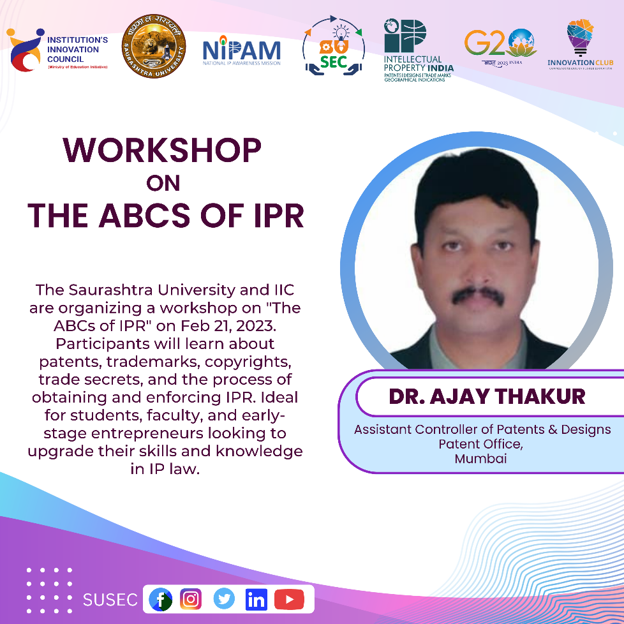

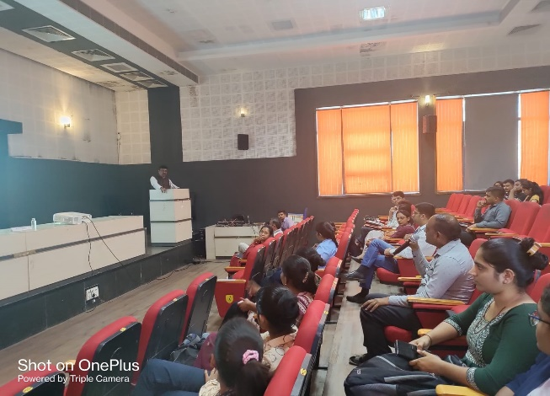
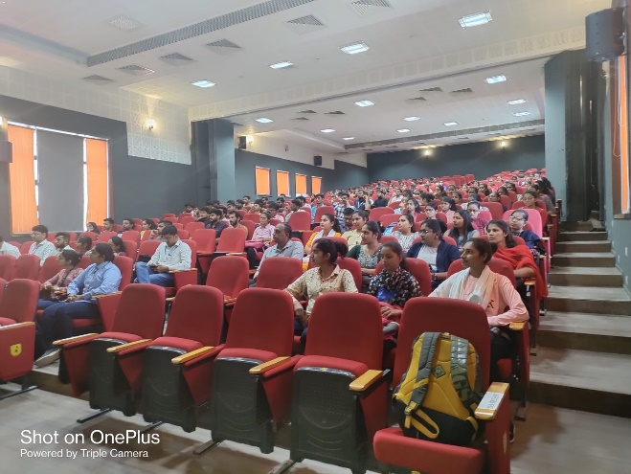
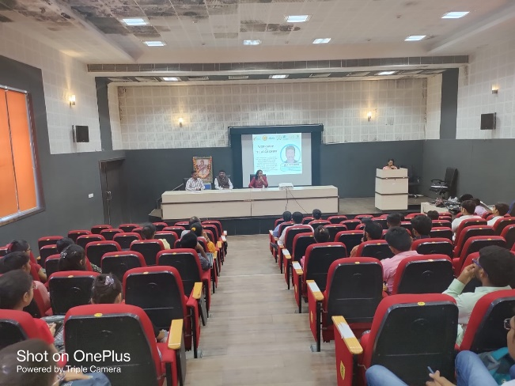
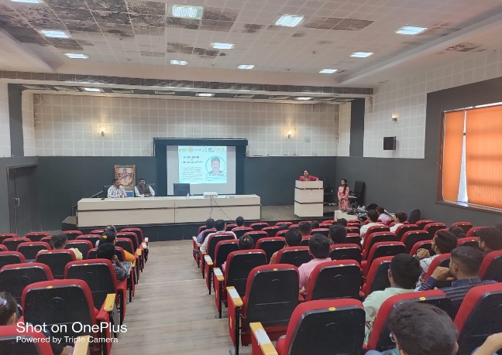
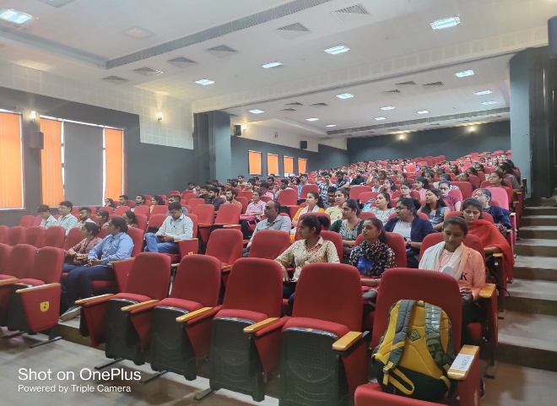
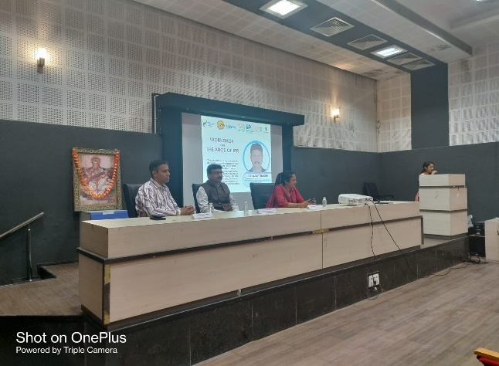

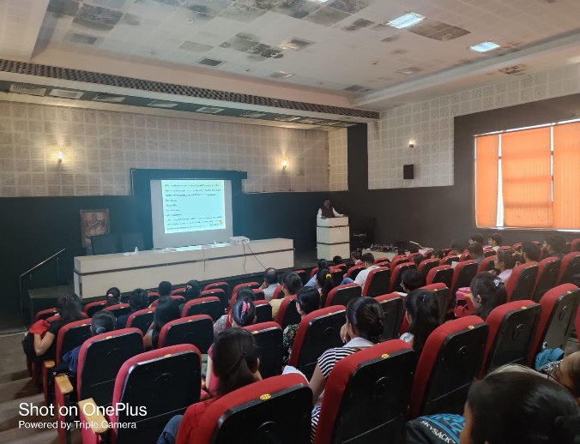
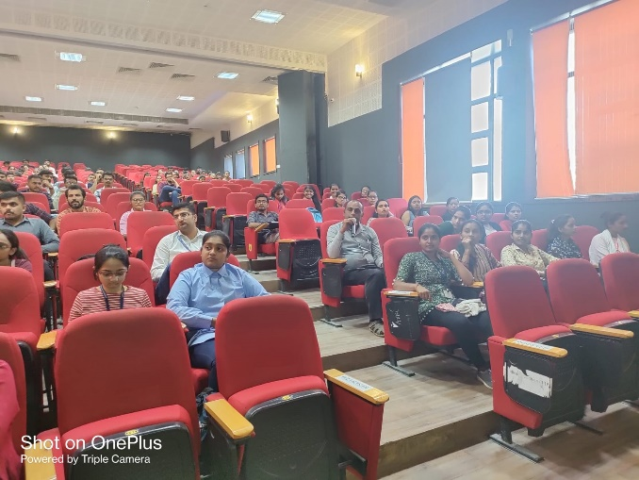

Connect Us:

https://www.linkedin.com/company/susec iic@sauuni.ac.in
https://www.facebook.com/iicsauuni bit.ly/SU-SSIP Location
https://www.instagram.com/susecrajkot

